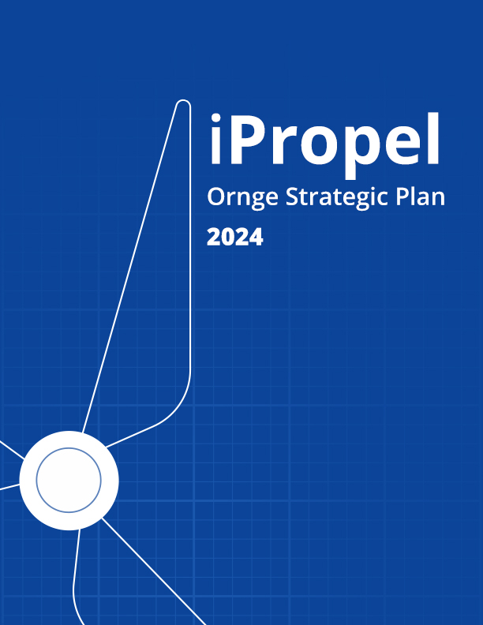

Letter from the CEO
On January 4, 2020, just two days after I took the reins of CEO at Ornge, the World Health Organization first signaled that there was a cluster of pneumonia cases of unknown cause in Wuhan, a city in central China. At that time, a total of 44 cases were reported. One year later, there have been over 90 million confirmed cases of COVID-19 globally and over 2.0 million deaths. This seismic event happened in Ontario and around the world just as we began planning for the next chapter in our organization’s history: Ornge’s Strategic Plan 2021 - 2024.
We have focused on key priorities – keeping our staff safe, developing clinical protocols for the safe transport of COVID-19 patients, adapting equipment, and contributing to Ontario’s COVID-19 response and vaccination efforts. While doing so, however, these recent challenges have caused us to carefully consider our place within the provincial healthcare system and how we can best contribute our unique skills and expertise for the benefit of our patients and partners.
I am pleased to present our Strategic Plan 2021-2024. This plan will guide us as we stretch even further to achieve the best possible outcomes for our patients and provide innovative approaches for better integration of care throughout the province.

Dr. Homer Tien
President and CEO

Operating Environment and Vision
Ontario is vast - our population of over 14 million is spread out over 1 million km², an area larger than France and Spain combined. Geography is a major determinant of health for Ontarians; patients in northern and rural Ontario face inequitable access to care and may suffer adverse outcomes as a result. For example, first line emergency care looks different in remote Indigenous communities compared to large metropolitan centres. In Toronto, skilled paramedics resuscitate on scene and then drive patients a short distance to emergency departments located within world-class quaternary hospitals. In some remote northern communities, there are sometimes no paramedics and no local emergency departments. Patients who reside in these communities often need to board an air ambulance for an hour flight before even seeing an emergency physician.
Ornge is Ontario’s air ambulance and critical care transport provider. We have fixed-wing (FW) and rotor-wing (RW) aviation assets, as well as critical care land ambulances (CCLA). Because of our province’s vast geography, any future vision of health equity in Ontario must involve Ornge and must consider transport. Our vision for Ornge is rooted in this perspective.
Our Vision:
The best care, wherever you may be
Our Motto:
Health Equity in Motion
Our Mission:
We save lives, restore health, create capacity and preserve dignity

Expanded Mission
We save lives.
- Our helicopters bring critical care capability to the scene to save the lives of critically ill or injured patients.
- Our air and land crews perform life-or-limb and emergency interfacility transfers. We can help staff at sending facilities with the acute resuscitation, and then rapidly transport patients to definitive live-saving care.
We restore health.
- In the North, geography is a major barrier to accessing diagnostic testing and specialist consultations. Ornge transports or organizes the air transport of all stretcher-bound patients in Ontario for diagnostic imaging and/or specialist consultation to help restore them back to health.
We create capacity.
- Ornge is asked to repatriate patients to hospitals closer to their home communities if air transport is required, and/or if patients require a critical care level of care during repatriation. This activity creates necessary capacity at hospitals to receive the next critically ill or injured patient.
- Ornge administers the Provincial Transfer Authorization Centre (PTAC) on behalf of the Ministry of Health. PTAC maintains a database of patient transfers within the province Ontario. In the event of an infectious disease outbreak, PTAC offers an online tool to screen for respiratory diseases prior to interfacility transport which can potentially reduce the likelihood of transmission, thereby preserving capacity in the system.
We preserve dignity.
- Ornge helps provide dignified end-of-life care. Ornge coordinates all aviation and critical care transport requirements in support of Trillium Gift of Life Network’s (TGLN) mission. This involves coordinating air transport for TGLN surgical transplant teams and for recovered organs. As well, Ornge transports patients back to their rural and remote communities to be with family and friends at the end of their lives.

iPropel Ornge
Our Strategic Propeller: iP⁴
The Ornge strategic propeller will help us achieve our vision and mission over the next three years. Our strategic propeller comprises:
ip1. Invent Practice
ip2. Improve Processes
iP3. Integrate Provincially
iP4. Inspire our People
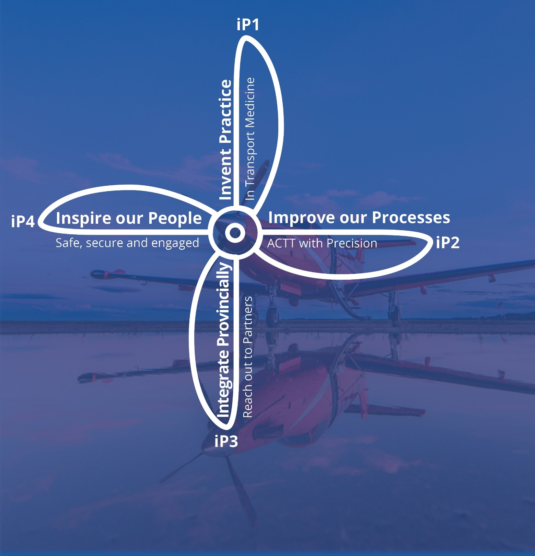

iP1: Invent Practice in Transport Medicine
Patients are our focus. As such, we need to ensure that we incorporate best practices in everything we do to achieve the best possible outcomes for our patients.
Critical care transport is a core part of our mandate. Ornge is the only paramedic provider of its kind in the province who can offer this level of care during transport. Best practices in critical care medicine are continually changing as new research informs new standards and guidelines. Most critical care research is hospital-based, so Ornge must adapt advances in critical care medicine to our setting, thereby inventing best practices for critical care transport medicine.
Ornge also plays a major role in providing equitable access to care for rural and remote communities, particularly for isolated Indigenous communities. Many residents of these communities need to board an air ambulance just to see a physician, get a radiograph, or to return home from hospital for end-of-life care. As such, Ornge also needs to ensure we adopt best practices to provide safe and dignified care for patients being transported for routine care and for end-of-life care. Ornge will also aspire to communicate our leadership and expertise in Transport Medicine, so others may learn from us.

iP2: Improve our Processes to achieve operational excellence
To achieve operational excellence, Ornge needs to overcome many challenges in order to successfully accomplish our mission. We need to have appropriately trained pilots and paramedics at each of our 12 operational bases on a 24/7 basis. At the same time, we need to have safe and operational airplanes, helicopters and land ambulances. Because we respond to emergency life-threatening and non-urgent calls, we need to ensure that each request for service is appropriately prioritized and that the right asset is sent to the right place at the right time. We have to do these things properly each time in the face of weather challenges and volume issues and over an immense geographical area of responsibility.
Therefore, to achieve operational excellence, we will improve our processes so that we ‘ACTT’ (Access, Capacity, Training and Transport) with Precision.
Access: We will explore innovative ways to help rural and remote communities access the care they need, either by transporting to higher level of care or sometimes while remaining in their communities.
Capacity: We will explore innovative ways to help rural and remote communities during surges in demand, whether from mass casualty events or pandemic.

Training: We need to ensure that our staff – particularly our front-line pilots and paramedics – is appropriately trained to safely and effectively complete their missions.
Transport: We need to make sure we have the right aircraft and vehicles available and ready to complete our missions.
Precision: We need to make sure we get the right patient to the right place with the right asset at the right time.

iP3: Integrate Provincially
Ornge is one of the few health care organizations in Ontario whose service delivery mandate spans the entire province, and we are the only agency that is specifically tasked with transporting patients provincially across municipal and regional borders. The government of Ontario and the Ministry of Health (MOH) also has, as one of their major priorities, the ambition to better integrate care throughout the province. Ornge is uniquely placed to facilitate that goal, especially as the health care system moves closer to a hub-spoke model, where patients are transported to tertiary care centers for higher levels of care. We are also uniquely placed to facilitate innovative solutions for system integration, as we have done during Ontario’s response to COVID-19.

iP4: Inspire our People
We will inspire our people to achieve our strategic plan and to propel Ornge forward over the next three years. We will encourage equity, diversity and inclusion to get the best members for our team; we will ensure that our team members feel safe, secure and supported to achieve our standard of excellence. We will ensure that they are well-equipped, well-resourced and well-trained to get the best results.
By “Inspiring our People”, we hope to Live our Corporate Values:
- Kindness
- Respect
- Integrity
- Safety
- Professionalism

The Lynchpin
The hub or “lynchpin” of our strategic propeller is that we will be SAFE in everything we do:
S: Safe.
Aviation safety, patient safety and staff safety will always be at the core of our efforts.
A: Accountable.
We will be accountable and transparent in all our actions and decisions.
F: Fiscally responsible.
We are stewards of public funds. We will be fiscally responsible in how we spend public dollars to achieve our mission and vision.
E: Equitable.
We will strive to improve equity by improving access to care, particularly for vulnerable populations. We will also strive to encourage equity, diversity and inclusion within our organization by reaching out, encouraging and mentoring our employees who belong to vulnerable communities.

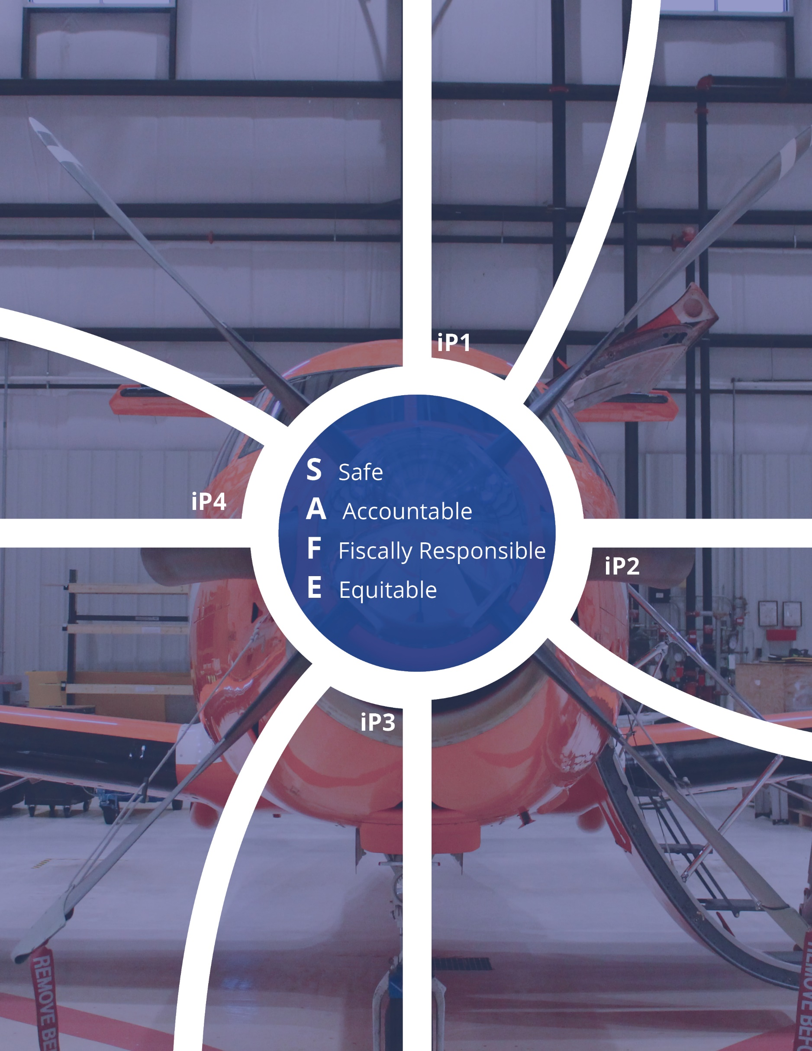

iPROPEL4: Implementation Plan
Implementation of the Strategic Plan will occur through a set of major tasks.

Major tasks for iP1:
- Implement a strategy to improve prehospital airway management and ventilation.
- Implement a strategy to improve transfusion and resuscitation in hemodynamically unstable patients.
- Implement a strategy to improve diagnostic accuracy in the prehospital setting using point-of-care laboratory tests and ultrasound.
- Ensure our contracted service delivery partners use the same electronic patient care records, thereby allowing for better data collection and improved oversight. This will help the Standing Agreement carriers provide the same standard of care as provided by our Ornge-dedicated paramedics.
- Develop a plan to provide safe and timely transport of palliative patients for dignified end-of-life care.

Major tasks for iP2:
- Implement strategies to improve access to care in order to improve outcomes in rural and remote settings. These include point-of-care testing, virtual care and enhanced education for providers in remote communities which may help to identify instances where transfer is not needed if care can be provided locally.
- Mitigate the effects of sudden surges in critically ill or injured patients by developing Ornge surge response capacity. This process will mobilize an Ornge Surge Response Team on short notice to provide logistical and clinical support for communities during surge. To integrate the Surge Response team into the provincial response, we would develop a partnership with the Emergency Medical Assistance Team (EMAT), so that our Surge Response Team could transition into EMAT operations.
- Ensure that our paramedics are trained using a just-in-time training approach. This will be a comprehensive revamping of our training curriculum that requires capital investment, is largely cost-neutral (offset by reduced travel and related costs), is operationally more effective and provides better training.
- Review our asset mix by initiating the fleet renewal process for RW and FW assets.
- Improve alignment between Ornge’s fleet maintenance cycles and operational patterns.
- Invest in CCLA, which provides a cost-effective alternative for transporting patients over shorter distances in urbanized areas (compared to RW or FW assets).
- Most importantly, focus on improving the precision by which our Operations Control Centre selects and dispatches assets.

Major tasks for iP3:
- Implement organizational changes to align internal and external communications with our stakeholders. Our stakeholders include municipal Paramedic Services, Central Ambulance Communications Centres, and government, hospital and other organizations.
- With CritiCall and government partners, improve system oversight of all emergent and urgent transfers and promote innovative system solutions for optimization of non-urgent interfacility transfers. One way to do this is by using PTAC as a digital means for evaluating performance of all interfacility transfers in the province in order to inform and apply best practices and performance standards.

Major Tasks for iP4:
- Having been named one of the GTA’s Top 100 employers in December 2020, we aim to be one of Canada’s Top 100 employers, incorporating best HR practices for our employees.
- Focus on Equity, Diversity and Inclusion (EDI), by appointing an EDI committee and executive sponsor, and developing an EDI roadmap for the organization.
- Ensure training in Change Management and EDI for our staff members – two priority areas for improved understanding and internal alignment.

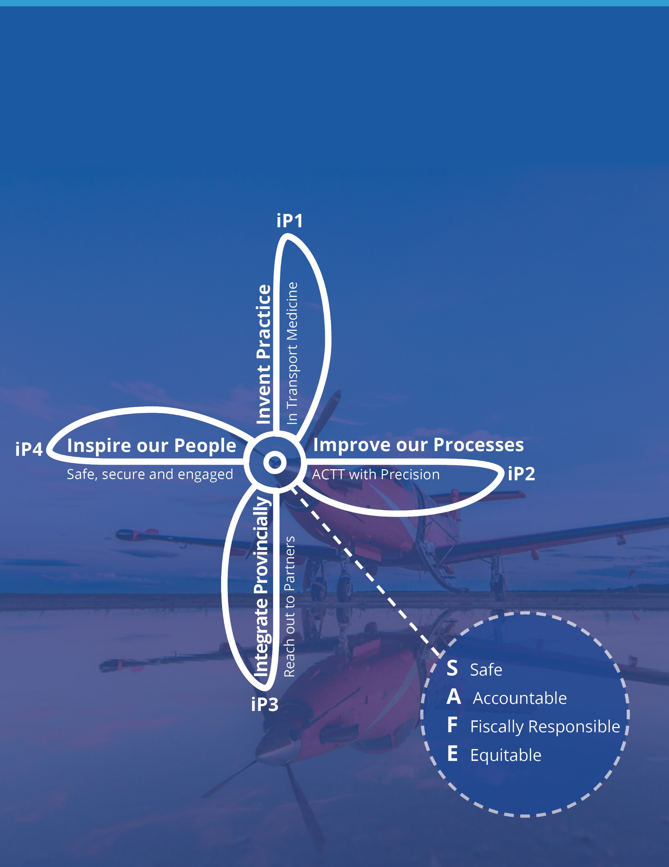

About this Plan
Ornge began its strategic planning process with an extensive review of our operating environment. We considered the impact that clinical developments are having on transport medicine and new opportunities for improving access to care, most especially for patients in the North. While doing so, we focused on the importance of equity, diversity and inclusion in terms of culturally sensitive and appropriate care to all Ontarians. We also have the ambition of being an employer of choice for visible minorities, Indigenous peoples and LGBTQ2S+ members.
We gathered feedback on our proposed strategic directions from our patients and their families, our health care delivery partners across the province and our staff throughout the entire organization. We are grateful for their insights and look forward to working collaboratively on specific initiatives and reporting on progress as we move forward in implementing our strategic propeller.
We will continue to track and monitor our organizational performance through our annual report, our annual Quality Improvement Plan, our annual Business Plan and other routine internal reporting. Through these mechanisms, we will track our progress in implementing the Strategic Plan.

