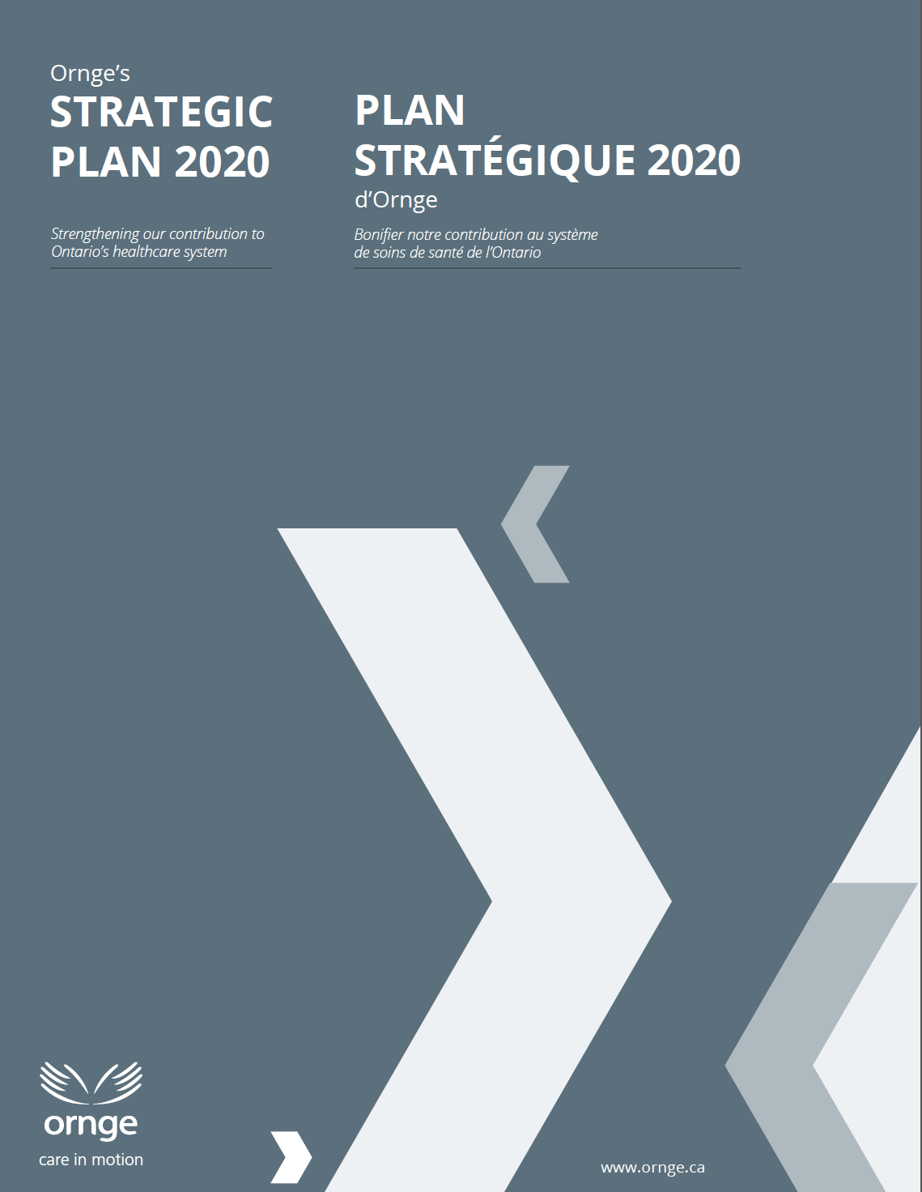
CEO’s Message
This is an exciting time for Ornge. Over the next three years, we will be contributing in new ways to healthcare in Ontario, building on our “connect and integrate” role in the provincial health system.
Our 2017-2020 Strategic Plan builds on the foundation of the 2014-2017 Plan. We challenged the organization’s fundamentals during this planning process and concluded that the delivery model is sound and that our strategic goals with some fine-tuning continue to be appropriate.
So what’s new? Plenty. We are supporting the Truth and Reconciliation Commission’s call for improved access to healthcare for remote First Nations communities. We are working on improved partnerships with other healthcare organizations to achieve better outcomes for patients with time-sensitive conditions such as trauma and stroke, and improved support for hospital-based transport teams such as neonatal/pediatric teams. We are also continually improving our overall operational efficiency and effectiveness.
I invite you to explore our 2017-2020 Strategic Plan and hope you share our enthusiasm in our efforts to improve outcomes for patients across Ontario and to enhance coordination and integration with partner organizations in the healthcare system.
Dr. Andrew McCallum
President and CEO

Contents
Introduction 3
Our Planning Process 3
Strategic Foundation 3
Guiding Principles 3
Mission, Vision, Values 4
Our Operating Environment 4
Environmental Scan 4
Advice from Stakeholders 6
Strategic Goals and Priorities 7
Goal 1: Focus our efforts and resources on activities that improve patient outcomes 7
Goal 2: Lead and support initiatives that improve coordination and integration with system partners 8
Goal 3: Improve service efficiency and effectiveness 9
Goal 4: Be a learning and engaged organization 9
By 2020 10

Introduction
Ornge’s Strategic Plan 2017-2020 provides a three-year outlook on initiatives that will enhance our patient care and transportation services and our integration with system partners. The Plan supports key goals of Ontario’s Ministry of Health and Long-Term Care including improving access, coordination, integration and sustainability of our healthcare system. Our Plan builds on our strengths, and identifies the opportunities and challenges that we face. The Plan identifies our strategic directions and specific priorities that we will implement in order to bolster our organization’s contribution to Ontario’s healthcare system.

Our Planning Process
To set the context for the planning process, an environmental scan and review of organizational strengths, weaknesses, opportunities and threats was undertaken. Key stakeholders and staff were broadly surveyed, and over the course of several months, almost sixty follow-up interviews were completed. Trends, issues and opportunities were identified and formed the basis of draft proposals for discussion at a strategic forum. The outcome is our strategic directions and priorities for 2017 – 2020.
Several assumptions underlie the development of the Plan:
- Improving quality, safety and efficiency are not mutually exclusive goals.
- Improved integration is a shared goal of all Ontario healthcare providers and funding agencies.
- System changes can be successfully implemented with broad support by system partners.

Strategic Foundation

Guiding Principles
Ornge has adopted the following four principles as cornerstones for success. We believe that these are hallmarks of a high performing healthcare organization.
- Service to Patients: Collectively and as individuals, our efforts should be focused on providing the best possible care to achieve optimal outcomes for our patients.
- Safety: We are committed to maximizing patient and employee safety by minimizing risk and being vigilant regarding safety issues in our diverse operating environments.
- Efficiency and Effectiveness: We strive for cost-effectiveness while delivering high quality services.
- Stewardship: We are stewards of public funds and public trust.

Mission, Vision, Values
Our Mission in Action
Ornge’s core business is providing timely patient transportation involving a range of paramedical services, by air and by land, including:
- Emergent and urgent interfacility transport
- Emergent scene response
- Repatriation of interfacility patients
- Non-urgent transport based on geographic and population needs
- Support for healthcare in remote communities through new and innovative approaches
- Provincial Transfer Authorization Centre (PTAC) authorization in support of public health objectives
- Transportation related to organ transplant

Ornge’s mission statement has been fine-tuned to shift the emphasis toward access to healthcare, instead of only “transport”. While our main focus is transporting patients, we can also provide direct patient care and support our partners in providing care whether or not the patient is ultimately transported.
- Mission: Providing Ontario’s patients with safe and timely care, transport and access to health services
- Vision: A trusted and responsive partner extending the reach of healthcare in Ontario
- Values:
  - Safety
  - Preparedness
  - Integrity
  - Compassion
  - Excellence

Our Operating Environment

Environmental Scan
Factors impacting demand for patient transport services:
- Repatriations: Increasing demand for repatriation from quaternary/tertiary hospitals to community hospitals with possible increased demand for non-urgent transports, including non-urgent transports requiring advanced/critical care (i.e. ICU to ICU repatriations to home hospitals).
- Regionalization: New hospital-based services cause changes in referral and transport patterns. Increasing regionalization of hospital-based specialized services (e.g. diagnostic services; stroke centres), with possible increased demand for transport along certain corridors.
- Telemedicine: Increasing use of telemedicine across the healthcare system, including by Ornge’s Transport Medicine Physicians. Facilitates better triage and provides more opportunities for patient care in situ, with possible decreased need to transport certain patients.

Factors impacting supply of patient transport services:
- Land Paramedic Services: Land paramedic services are increasingly focused on their core mission, being 911 emergent responses, and less on non-urgent inter-facility patient transports. Due to resource constraints, some Services are putting limits on response on non-urgent transports between airport and hospital resulting in delays.
- Medical Transport Services: Hospitals and Ornge are increasingly reliant on private medical transport services rather than land paramedic services – an unfunded expenditure.
- Growing concern about financial viability of small municipal airports with some at risk of closure. Some airports are putting limits on winter maintenance.
- Regulations/Standards: Requirements for ambulance services are written with land services in mind, which can be misaligned with air ambulance regulatory requirements.
Ornge context:
- Organizational stability. Improved reputation.
- Excellent patient care delivered by skilled personnel and service delivery partners.
- State-of-the-art assets.
- Province-wide reach.
- New connection to the Ontario Telemedicine Network.
- Fiscal constraints, with an ongoing need to invest in safety, availability and quality of care.
Broader healthcare system context:
- Resource Constraints: The need to be resource-conscious is creating a good climate for collaboration.
- First Nations Communities: Ongoing pressure on Nursing Stations to address the diversity of healthcare needs including acute and chronic conditions. Ongoing challenges re: access to care.
- Northern Ontario: Ongoing shortage of specialist, obstetrical care and primary care services impacting patterns and volume of time-sensitive and non-urgent transports.
- Special Patient Populations: System challenges in addressing transportation needs of special patient populations, including bariatric patients, and patients transported for mandatory psychiatric evaluation under the Mental Health Act from northern and remote communities.
- Hospital-Based Teams: New focus on hospital-based specialized transport teams is impacting operations for Ornge and land paramedic services.
- Demographic: “Aging in place” trend in rural and northern communities, with possible increased demand for transports.

Advice from Stakeholders
Stakeholders interviewed indicated a noticeable improvement in Ornge as a system partner over the past three years – a trend which is also reflected in Ornge stakeholder satisfaction survey results. The following themes emerged:
- Transportation is important for managing hospital patient flow and bed allocation. Paramedic Services indicate that non-urgent interfacility transports are a significant strain on resources and are not their primary role. Suggestion that this may provide some opportunity for Ornge to fill a need, and that Ornge should review potential strategies for facilitating repatriations. Growing interest in Critical Care Land Ambulance (CCLA) program expansion.
Ornge questioned approximately 20 external stakeholders as follows:
1. What do you see as Ornge’s key strengths?
2. What one or two things could we do differently that would make a difference?
3. As a system integrator, Ornge helps patients to access the care they need. We have air and land ambulance vehicles and skilled paramedic crews. But in addition, we have a 24/7 physician presence, a small team of educators, and in-house expertise in pharmacy and medical equipment/ supplies. With this in mind, can you please comment on whether you see opportunities for Ornge to contribute more or differently within the health care system?
4. Does your organization have future plans that we should be aware of?
- Challenges continue to face the North. Many saw benefits in providing care closer to home for remote communities (leveraging telemedicine/telepsychiatry). Suggestion that Ornge evaluate landing site locations and base/fleet locations in relation to major receiving centres and examine the potential to carry more than one patient at a time.
- There are opportunities for further collaboration with healthcare partners.
- Strong desire among healthcare partners for more timely information from Ornge during a patient transport, particularly updates on arrival times. Overall interest in streamlining Ornge’s dispatch processes, which are sometimes lengthy and duplicative.

Strategic Goals and Priorities
Taking into consideration our operational environment, and building upon our recent efforts, we have charted a course for the next three years. Our goals remain similar to our previous strategic plan and we have identified new priorities aimed at improving service to patients and leveraging our capabilities to contribute more within the healthcare system.

Goal 1: Focus our efforts and resources on activities that improve patient outcomes
Service to patients is at the centre of Goal 1. We aim to use our assets and apply our efforts in a way that brings the greatest medical benefit to patients across the province – right patient, right care at the right time. We aim to be innovative in improving care and access for patients with time-sensitive conditions and for residents of remote communities in Ontario’s far north.
Priority 1.1 Improve system access for remote First Nations communities.
- Clinical Initiatives: Collaborate with northern hospitals on expanded clinical support for nursing stations via telemedicine. Consider opportunities for standardization of certain medical equipment.
- Support for Nursing Stations: Contribute to continuing medical education for nurses in remote Aboriginal communities, focusing on transport and critical interventions. Work with government partners on other opportunities for support.
- Data: Lead collaborative efforts to gather and analyze data in support of system improvements.
Priority 1.2 Improve access to definitive care for time-sensitive patients.
- Arrival at Hospital: With hospital stakeholders, develop processes to expedite care for specific time-sensitive patients (e.g. direct to CT scan for selected trauma or stroke patients, direct to interventional suite for acute cardiac patients).
- Stakeholder Outreach: Continue to educate stakeholders about our service, reinforcing beneficial air ambulance utilization practices with reference to the patient’s condition and health care requirement (e.g. using modified scene calls for trauma, stroke and STEMI patients that derive a time benefit in reaching definitive care and/or level of care required to safely transport the patient). Engage healthcare partners to identify opportunities to better coordinate the timing of clinical services with respect to the timing of transportation, and vice versa.
Priority 1.3 Strengthen other aspects of service delivery that lead to improved patient outcomes.
- Response Time Initiatives: Standardize crew mobilization protocols and operational environments. Further streamline the dispatch process.
- Single Level of Care: Continue to pursue our ‘Single Level of Care’ target of staffing assets at the Critical Care level.
- ‘Tech Watch’: Develop a program to systematically scan and assess novel medical technologies for application in the field.

Goal 2: Lead and support initiatives that improve coordination and integration with system partners
Ornge is a system integrator connecting patients with care, often over long distances and sometimes involving complex medical care. Over the last several years we have worked to strengthen strategic alliances with other healthcare organizations including land paramedic services, Central Ambulance Communications Centres (CACCs), CritiCall Ontario as well as other provincial healthcare organizations and hospital-based specialized programs. Ornge aims to collaborate further with partners so that, collectively, we provide excellent and seamless patient care.
Priority 2.1 Collaborate on service improvements for special patient populations.
- Neonatal/Pediatric and ECMO Patients: Work with hospital-based neonatal/pediatric and extracorporeal membrane oxygenation (ECMO) transport teams, and land paramedic services to develop collaborative solutions that meet the unique needs of team transports.
- Bariatric Patients: In partnership with land paramedic services and our contracted carriers, lead efforts to develop more consistent processes for air ambulance transport that meets the unique needs of bariatric patients.
Priority 2.2 Further support the One Number to Call initiative.
- Repatriations: Contribute to improved system-wide patient flow by facilitating repatriation from specialized hospital care to closer-to-home hospital care at the earliest opportunity.
- CritiCall Ontario: With CritiCall Ontario, explore further integration of patient referral, triage and transport processes.
Priority 2.3 Improve connectivity with system partners.
- Integration with Hospitals: Improve real-time communication with hospitals, including streamlined intake processes and improved flow of information on crew ETA.
- Integration with CACCs: Work with government partners to electronically connect Ornge’s dispatch centre with CACCs.
- Post-Graduate Medical Trainees: Implement a program to familiarize post-graduate medical trainees regarding issues in transport medicine including career opportunities among resident physicians, while enriching our operational environment at the same time.
- Crew Communication: Work with system partners to improve interoperability among land and air crews.

Goal 3: Improve service efficiency and effectiveness
Ornge is committed to delivering high quality care while assuring safety and operational performance. We work at the confluence of two highly regulated sectors – aviation and healthcare – and are also accountable for meeting broader public sector requirements. Goal 3 focuses on initiatives that promote efficient and effective service delivery.
Priority 3.1 Improve service utilization and reliability.
- CCLA Utilization: Increase utilization of the CCLA program. In the Ottawa area, increase call volume through streamlined dispatch and education/marketing for client facilities. Work with government partners on possible targeted expansion or redistribution of CCLA services based on geography and transport patterns.
- Service Reliability: Improve service reliability by reinforcing positive workplace practices and efforts related to reliable attendance at work. (Linked to Goal 4).
Priority 3.2 Maintain an ongoing outlook for service improvement ideas, and study ideas for long-term service and system adaptations.
- Fleet and Bases: Begin to consider future fleet needs – asset capabilities/configurations, asset mix including fixed wing short take-off and landing capability. This will be the focus of a subsequent Strategic Plan.
- Landing Site Infrastructure: With government and other stakeholders, explore long-term principles for runway and helipad infrastructure in support of access to healthcare.
- Staffing: Review crew and dispatch staffing configurations to ensure an optimal skill mix with the aim of maximally streamlining the dispatch process. Identify suitable northern and indigenous sources of recruitment and develop paths to facilitate entry to our occupations (paramedic, pilot, aircraft maintenance engineer, communications officer etc.)
Priority 3.3: Continue to work with the Ministry of Health and Long-Term Care in relation to the structural funding gap.
- Continually improve systems and processes to achieve cost-efficient delivery of high-quality services.
- Identify alternative revenue streams in collaboration with government.

Goal 4: Be a learning and engaged organization
As a learning organization, we aim to continuously adapt to our operating environment by collecting, interpreting and using information in a way that contributes to safety, problem solving and good decision-making. As an engaged organization, we aim to vigorously promote our successes in achieving our mission so that our staff feel fulfilled and acknowledged in their role in achieving our success. Our staff indicate that there is room for improvement from an engagement point of view. We recognize that corporate culture influences employee engagement and is linked to service reliability. Therefore we have identified corporate culture as a strategic priority.
Priority 4.1 Shift culture in a positive direction so as to improve engagement and service reliability.
- Strengthen head office and frontline connections in our widely dispersed organization.
- Internal Alignment: Improve the ways in which we work together in support of our mission and priorities.

By 2020
Ornge’s Strategic Plan 2017-2020 is an ambitious, achievable and solid plan for the next three years. It sets out the key priorities underlying our commitment to delivering safe and timely transport and access to health services. Many of our milestones will be met in collaboration with other healthcare partners, which we view as essential for maximizing the outcomes of Ontario’s healthcare system more broadly. As needed, the strategies set out in this document will evolve to remain current and reflect changing circumstances.
Ornge’s Board of Directors and staff are committed to operationalizing the strategic goals, priorities set out in the plan. Progress will be monitored regularly to ensure that we move steadily toward our vision of being a trusted and responsive partner extending the reach of healthcare in Ontario.

“Aging in place” is a term used to describe the circumstance when older people remain living in the community with some level of independence rather than in residential care.

